 **24 Apr 2015** **The Weekly Bulletin of Rotary Club of Kathmandu Mid-Town** **bc-41/4.015**

|  |
| --- |
|  |

District: 3292 Web:www.rotarymidtown.org.np Club Id: 26776

**APRIL IS THE MAGAZINE MONTH**

**The purpose of the magazine is to advance the Object of Rotary in all its aspects.**

Club’s Weekly Meeting # 1275 on Friday, 17 April:

Extracts of the Minutes :

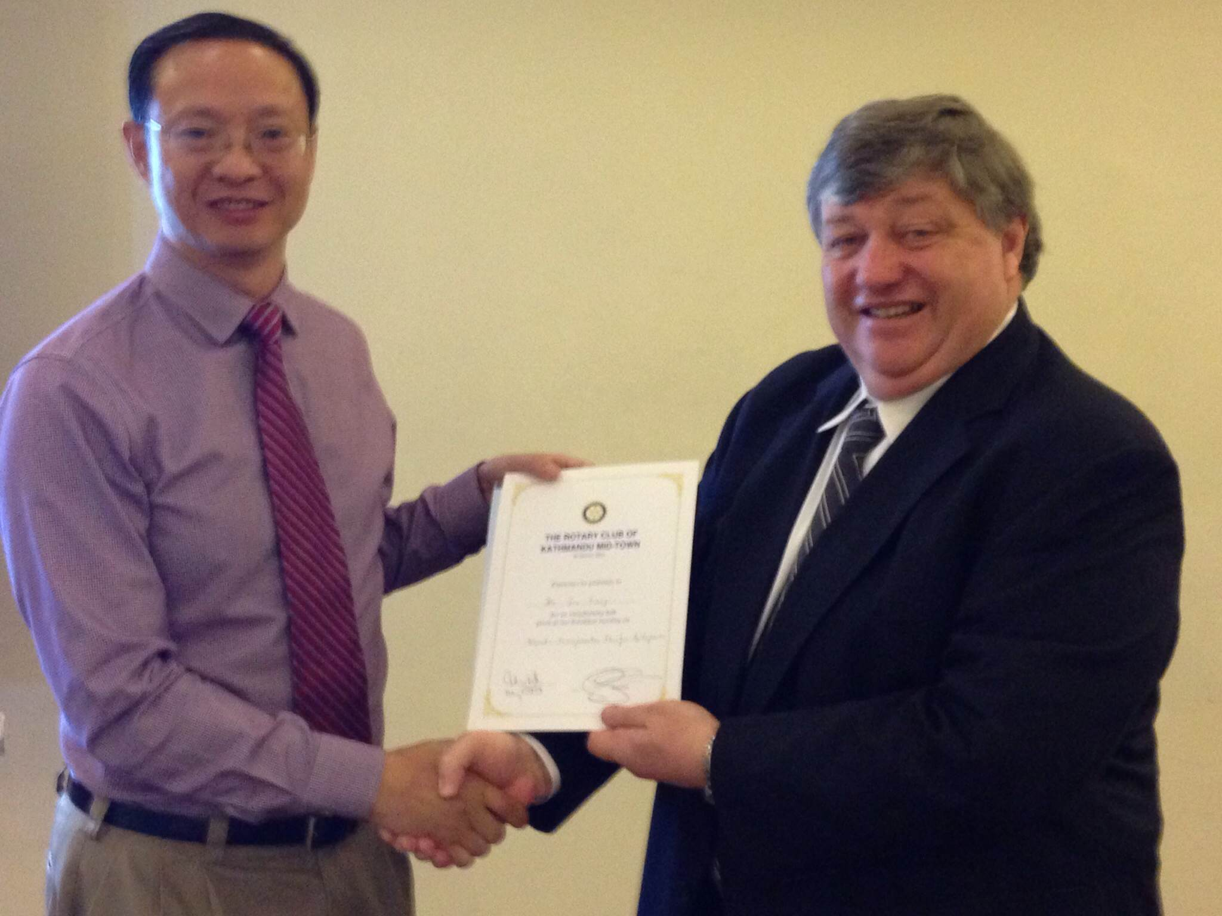

“1. 1st VP HE Peter Bodde called meeting #1275 to order

“3. VP Peter welcomed the Mid-Towners. Ms Fiona Heiton (First Steps Himalaya)

joined later in the meeting..

“7. Our speakers Mr Jie Tang (World Bank Group) was introduced by Rtn Larry

Kelly. He spoke on the topic of, "Nepal: Transformation Plan for Hydropower".

Mr Tang has spent the past three decades working in the area of hydropower

and the past decade and a half working for the World Bank in this area. His

talk covered 5 areas: 1: Overview and Electricity Crisis in Nepal; 2: Hydro-

power Potential and a transformational opportunity; 3: Key Barriers to Hydro-

power Development; 4: Support of WBG’s institutions and 5: Expected

outcomes. He explained that the World Bank group is calling for a holistic

approach for the short term (to reduce load shedding; for the medium term (to achieve a supply-demand balance) and for the long term (to meet domestic demand and export hydropower for revenue). His enthusiastic presentation was greeted by many questions and the usual Q&A ensued. PP CK gave the vote of thanks entreating Mr Tang to please take Nepal out of the darkness.

”8. Information sharing:

> PP CK reminded that the trip to Baitadi to close the A&M project will take place on 7 May. Anyone interested in joining please contact PP CK.

> Board Members and Chairs were reminded to please submit their yearly reports at the soonest.

“9. Statistics of the meeting: Members present: 24”

# Weekly Meetings and Programs :

|  |  |  |
| --- | --- | --- |
| Date | Program/ Speaker | Topic of Presentation |
| 24 April | Prasun Jalan | ? |
|  |  |  |

Weekly Meeting on Friday, 24 April:

Mr Prasun Jalan is our guest speaker for the day.

He worked as a commodity trader in precious metals & Energy in Bulls.Beat Commodity Broking, Mumbai, 2006-2008; Worked as an Analyst in Investment Banking Division of Goldman Sachs, London/Bangalore (Investment Banking) with team involvement in various financing advisory in infrastructure & airlines companies in Europe including Sweden, from April 2008 to Sept 2009.

He is Managing Director in Urja Ventures Pvt Ltd, Kathmandu, Nepal. The company is involved in import and trade of Diamond & Gold jewelry in association with Gitanjali Group, one of the largest integrated jewelry manufacturing company in the world.

He also holds the position of Executive Director in TeleTalk Pvt. Ltd, Kathmandu, Nepal. The company is Nepal’s largest mobile handsets company.

He is CFA, level 1; He did Diploma in Stock Markets/Derivatives; Diploma in Tourism Management and Diploma in Investment Banking (M &A, IPO, Restructuring).

**District Training Assembly**

District Training Assembly is going to be held on 9 May 2015 in Little Angle's School, Hattiban, Lalitpur.  This is a very important District event and Incoming Club Officials: President-elect Club Secretary, Treasurer, Chair Persons of Five Standing Committees: Club Administration, Membership, Public Relation, Service Project and The Rotary Foundation are encouraged to attend the training assembly.

**Regional Magazines Distributed In Over 130 Countries!**

In 1911, Rotary decided it needed a magazine to inform club members. ***The Rotarian*** was born. Soon, Rotary club members around the world wanted publications they could call their own. In 1915, the first regional magazine was published, serving members in Great Britain and Ireland. In 1928, the predecessor to Rotary Down Under launched in Australia.

Today, the Rotary World Magazine Press is the umbrella under which Rotary’s 32 magazines flourish. Though The Rotarian is still the flagship publication, the 31 regional magazines are distributed in more than 130 countries and written in 25 languages. Rotary magazines in Annex.

*Source: Rotary International News*

**China’s pandas brew a top drop!**

China’s national treasure, the giant panda, will become even more precious if one businessman succeeds in using their dung to grow organic green tea he intends to sell for over $200 a cup. An Yanshi, an entrepreneur in southwest China, grows the tea in mountainous Ya’an in Sichuan province using tons of excrement from panda bears living at nearby breeding centers. The first batch of panda dung tea will be sold in lots of 50 grams that will cost some 22,000 yuan ($3,500) each, a price An Yanshi said makes it the world’s most expensive tea. .

*Source: The Rising Nepal*

Travel / Tourism

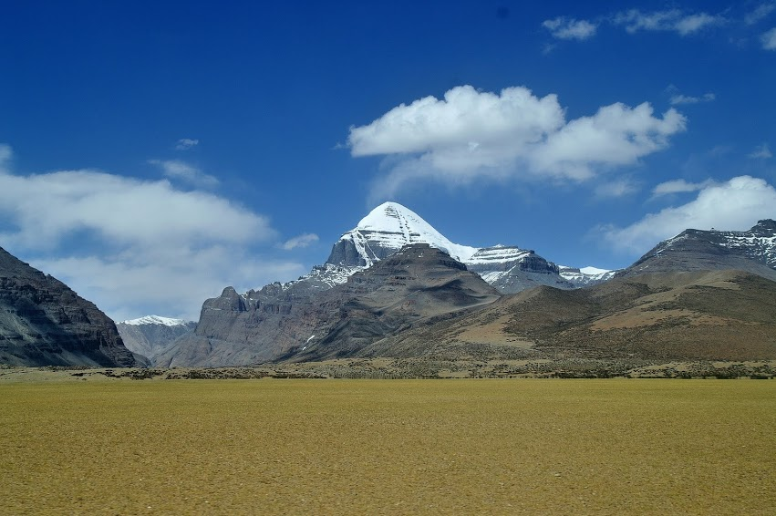

“The World is a book, and those who do not travel read only a page.”





**A THOUGHT FOR TODAY:**

**[The greatest analgesic, soporific, stimulant, tranquilizer, narcotic,](http://www.brainyquote.com/quotes/quotes/b/baruchspin101666.html" \o "view quote)**

**[and to some extent even antibiotic -](http://www.brainyquote.com/quotes/quotes/b/baruchspin101666.html" \o "view quote)**

**[in short, the closest thing to a genuine panacea -](http://www.brainyquote.com/quotes/quotes/b/baruchspin101666.html" \o "view quote)**

**[known to medical science is work.](http://www.brainyquote.com/quotes/quotes/b/baruchspin101666.html" \o "view quote)**[-Thomas Szasz, author, professor of psychiatry (15 Apr 1920-2012)](http://www.brainyquote.com/quotes/quotes/b/baruchspin101666.html" \o "view quote)

*[Courtesy: Rtn IsabellaC Bassignana Khadka](http://www.brainyquote.com/quotes/quotes/b/baruchspin101666.html" \o "view quote)*

On Lighter Side:

A very prestigious Cardiologist died,

and was given a very elaborate funeral by the hospital he worked for most of his life.

A huge heart, covered in flowers, stood behind the casket during the service

as all the doctors from the hospital sat in awe.

Following the eulogy, the heart opened, and the casket rolled inside. The heart then closed, sealing the doctor in the beautiful heart forever.

At that point, one of the mourners just burst into laughter.

When all eyes stared at him, he said,

“I'm so sorry... I was just thinking of my own funeral... I'm a Gynaecologist!”

**Cellphone Way of Life !!**

(More features of ‘cellphone way of life’ to follow)

  

*Courtesy: Rtn Dr Isabella C.Bassignana Khadka*

***The Rotarian*** is one of the oldest continuously published magazines in the world, with an

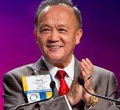

unbroken publication history dating back to its first issue, featuring Paul Harris as a

contributor, in 1911. …

Every month, *The Rotarian* brings us a snapshot of the best of the Rotary world: It engages,

entertains, enlightens, and inspires. …

*The Rotarian* isn't just enjoyable for Rotarians – it's a great way to boost Rotary's public image, and show the world the work that Rotarians do. …

Use it to Light Up Rotary – just as Rotarians have been doing for more than 100 years.

**RI President GARY C.K. HUANG**

## 24 April 2015 The Weekly Bulletin of Rotary Club of Kathmandu Mid-Town bc-41/4.015

******************************************

Annex

Rotary Regional Magazines

 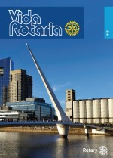  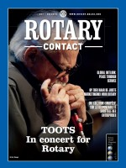

Africa Argentina Australia Belgium/Luxem

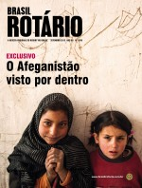 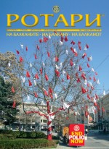 [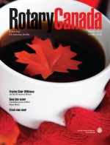](http://www.therotarianmagazine.com/rotarycanada) 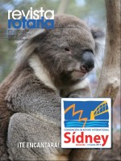

Brazil Bulgaria Canada Central American

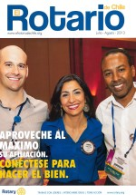 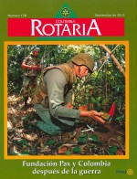  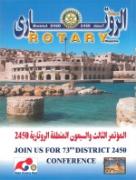

Chile Colombia Czech Egypt

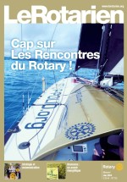 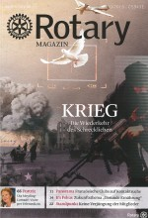 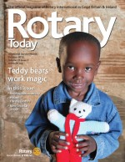 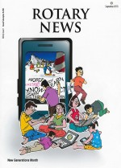

France Germany Great Britain India

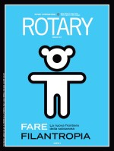 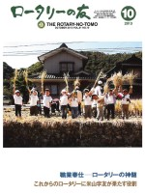  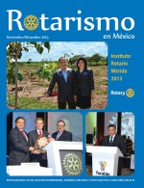

Italy Japan Korea Mexico

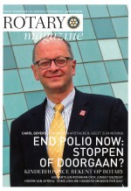 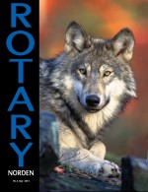  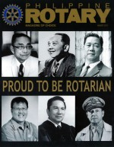

The Netherlands Nordic Countries Peru Philippines

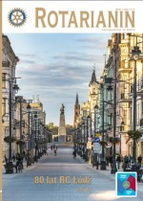 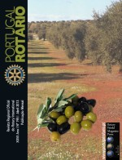 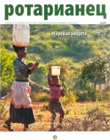

Poland Portugal Russia

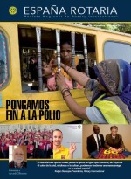 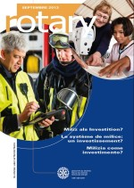 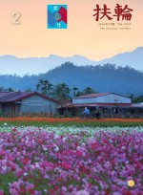

Spain Switzerland Taiwan

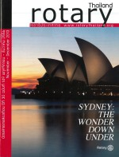 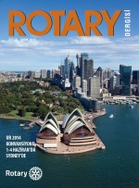 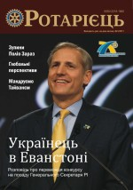

Thailand Turkey Ukraine